SS1 – New Organizational Units In savn.local.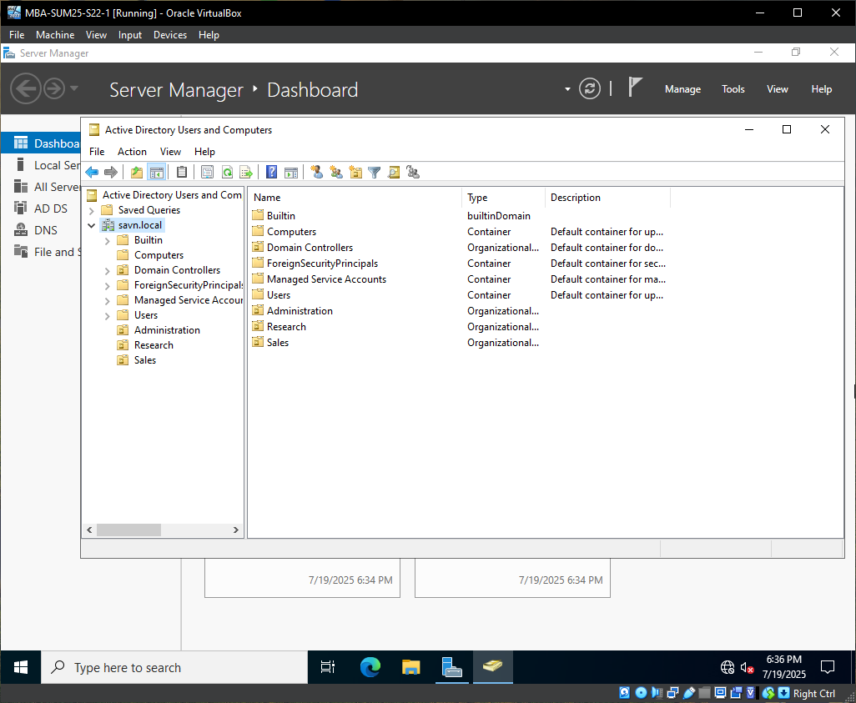
SS2 – Local user account created. 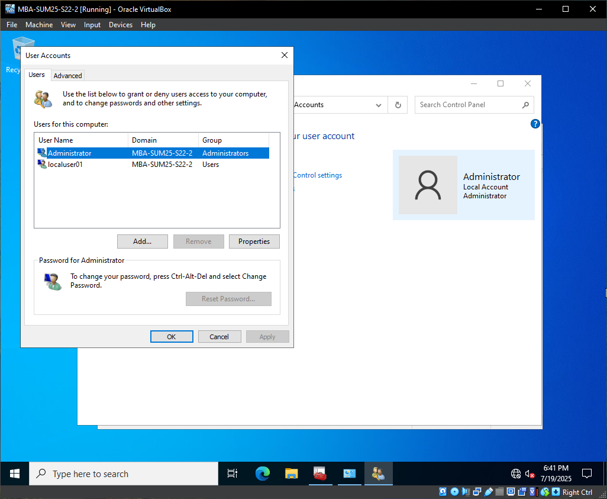
SS3 – New domain user account created. 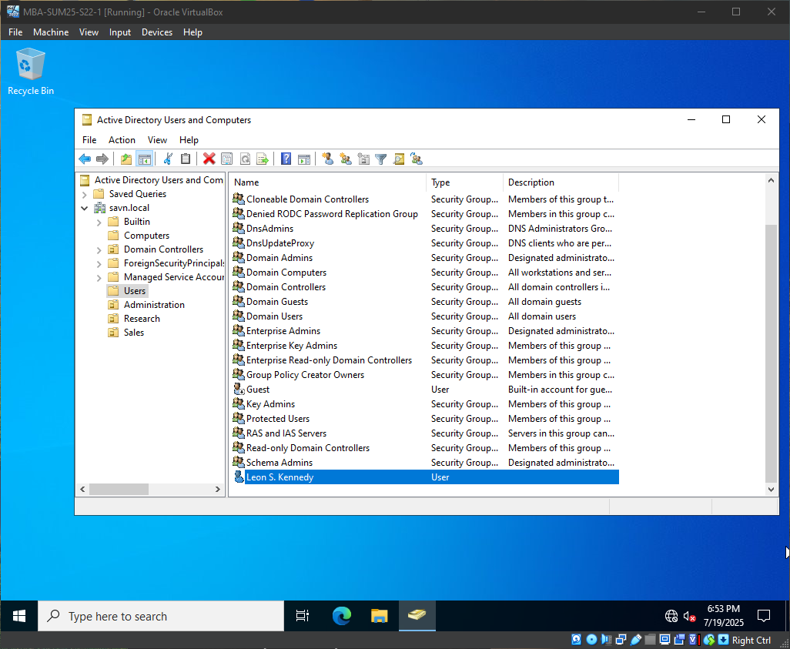
SS4 – domainUser01 account located in Administration OU. 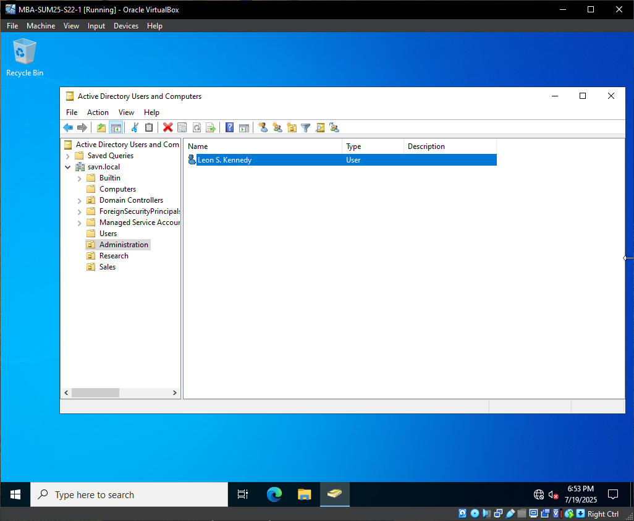
SS5 – localUser01 is logged into MBA-SUM25-S22-2 as a local (non-domain) user. 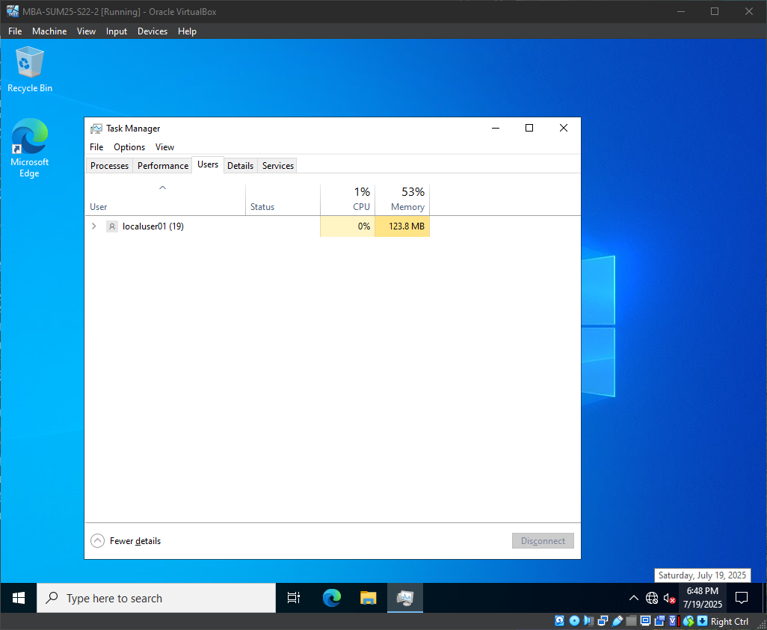
SS6 – Domain user logged into a system in the domain.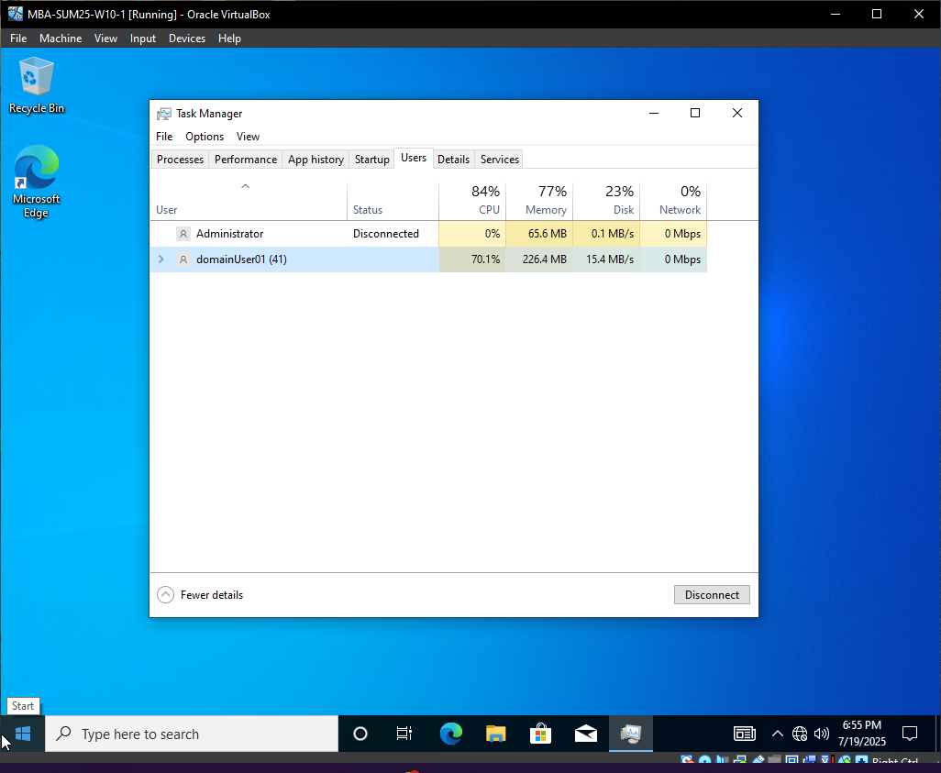
SS7 – Attempted domain login when domain server is unavailable.